EXPERIMENT – 5
Create a simple cloud software application for Library book reservation system for SIMATS library using any Cloud Service Provider to demonstrate SaaS.
AIM: To create and provide a simple cloud-based software application for Library book reservation system for SIMATS library using Zoho Creator to demonstrate the Software as a Service (SaaS) model.
PROCEDURE:
- Open a web browser and go to Zoho Creator website.
- Create a Zoho account and log in.
- Click on Create Application and select From Scratch.
- Choose Blank App and provide the application name as SIMATS Library book reservation system.
- Create a form named Membership and add fields such as Name, Phone, Email, College, Position and a checkbox for agreement.
- Create another form named Book Reservation and add fields such as Name, Membership ID, Library name, Book ID, Date of Borrow, Date of Return and a checkbox for Terms and Conditions.
- Mark the necessary fields as mandatory.
- Save the completed form and alter the visual themes.
- Configure user access and sharing settings to allow multiple users to use the application.
- Save the application and generate the application URL.
- Access the application through the URL using any web browser.

OUTPUT: 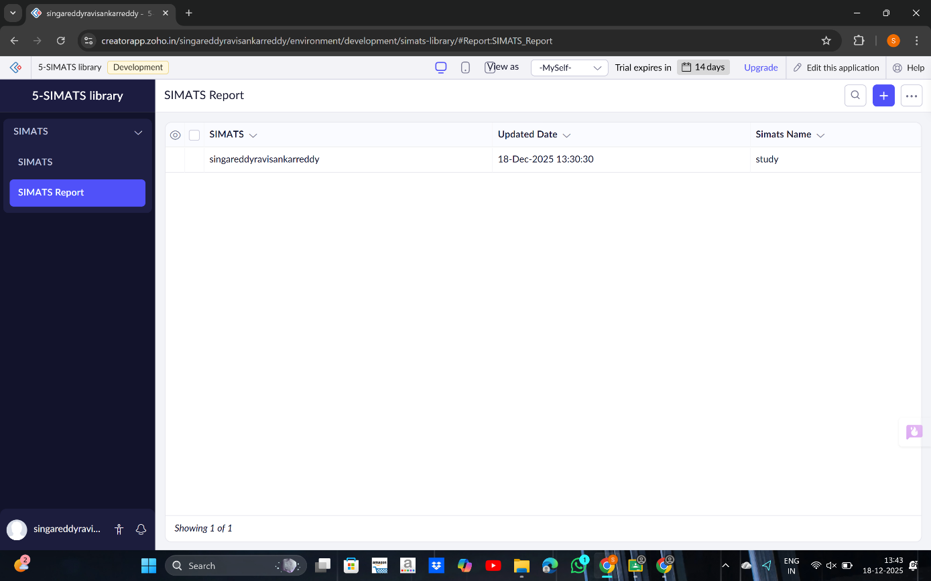

RESULT:
A cloud-based Library book reservation system for SIMATS library was successfully created and deployed using Zoho Creator. The application is accessible through a web browser without installation, and users can sign up for membership and reserve books, thereby successfully demonstrating the Software as a Service (SaaS) model.

